Exam 2 Review – ANSWER KEY

Review Multiple Choice Questions
- What type of data are correlations used for?
  - Discrete
  - Continuous
- What type of data are regressions used for?
  - Discrete
  - Continuous
- What type of data are chi-squares used for?
  - Discrete
  - Continuous
- What type of question do correlations answer?
  - What is the relationship between two variables? Are these variables associated with one another?
  - Can we predict variable Y from variable X?
  - Are there significant differences in the outcome variable across groups? Are there significant differences across group means?
- What type of question do chi-squares answer?
  - What is the relationship between two variables? Are these variables associated with one another? Is there a difference in frequencies across groups?
  - Can we predict variable Y from variable X?
  - Are there significant differences in the outcome variable across groups? Are there significant differences across group means?
- What type of question do regressions answer?
  - What is the relationship between two variables? Are these variables associated with one another?
  - Can we predict variable Y from variable X?
  - Are there significant differences in the outcome variable across groups? Are there significant differences across group means?
- What type of question do t-tests answer?
  - What is the relationship between two variables? Are these variables associated with one another?
  - Can we predict variable Y from variable X?
  - Are there significant differences in the outcome variable across groups? Are there significant differences across group means?
- What type of t-test would you use for each of the following questions (independent or related)?
  - Randomly assigning participants to one of two groups and comparing the averages across groups. Independent sample
  - Having participants participate in two different conditions at two different times and comparing averages across the two conditions. related
  - Randomly assigning participants to one of two groups and making sure that each participant from group A is matched on some characteristic (i.e., age) with a participant from group B and comparing the averages across the two groups. related
- Which p-values are significant (select all that apply)?
  - P = .01
  - P = .05
  - P = .07
  - P = .35
  - P = .004
  - P = .09
- Which of the following (select all that apply) would you report in your results write-up?
  - Test statistic (X², t, r)
  - P value
  - Degree of freedom
  - Group means
  - Confidence interval
  - N
  - Raw data

SPSS Practice Problems

- A doctor believes that the number of cups of coffee a person drinks is associated with their pulse. He surveyed 10 people and asked them how many cups of coffee they drink per day and measured their pulse in beats per minute. Is there a significant association between how many cups of coffee a person drinks daily and their pulse?

Cups of Coffee | Pulse (Beats per minute)
3  1  1  2  3  0  1  3  2  2 | 100  60  66  80  120  60  70  90  100  85

- What tests would you perform? Be as specific as possible

Correlation, could follow-up with regression if significant

- Based on your findings, write a sentence describing the association between cups of coffee and pulse rate (include statistical notation).

Greater coffee consumption was associated with higher pulse, r = .87, p = .001.

- Can you run a regression (yes or no)?

Yes

- If you drank 4 cups per day what would you expect your pulse to be? Show your work for how you arrived at your answer to get full credit.

Y = bx + a
Y = (16.688)(4) + 53.063
Y = 119.82

You would expect your pulse to be approximately 120.

2. A principal wants to know if there is an association between gender and getting into trouble. He asks a 3rd grade teacher to report to him every time they need to reprimand a student. Is there a difference in frequency of getting in trouble for girls vs. boys?

Girl Students | Boy Students
No Trouble  No Trouble  Trouble  Trouble  No Trouble  Trouble  Trouble  No Trouble  No Trouble  Trouble  No Trouble  Trouble | Trouble  Trouble  No Trouble  Trouble  No Trouble  No Trouble  Trouble  Trouble  Trouble  No Trouble  Trouble  Trouble
A. What test would you perform? Be as specific as possible.

Chi-square test of independence

B. Write a sentence describing if there was a significant association or not between gender and getting in trouble (include statistical notation).

There was no significant association between gender and getting into trouble, X²(1) = .69, p = .408.

C. What is the phi coefficient value, and is this a small, medium, or large effect size?

The phi coefficient is -.17, this is a small effect size.

3. A devious babysitter wants to see if she can trick children into believing that she has an invisibility cloak. She also believes that children will misbehave more often if they believe they are wearing an “invisibility cloak.” She babysits 8 children and counts the number of mischievous acts they complete on a regular day when they are not wearing an “invisibility cloak.” She goes back the next day and gives each child an “invisibility cloak” and again counts up the mischievous acts they engage in. Is there a significant difference in the average number of mischievous acts committed while wearing an invisible cloak compared to not wearing a cloak?

Child | Mischievous Acts without a Cloak | Mischievous Acts with Invisibility Cloak
1 | 2 | 5
2 | 4 | 11
3 | 1 | 5
4 | 0 | 4
5 | 3 | 6
6 | 2 | 6
7 | 1 | 5
8 | 1 | 7

A. What statistical test should you use to evaluate if the cloak significantly increases number of mischievous acts? Be as specific as possible.

Related samples t-test

B. Write a sentence describing the overall result of the analysis, include statistical notation.

The analysis showed a significant effect of presence of invisibility cloak on mischievous acts, t(7) = -8.79, p < .001.

C. Write a sentence describing the specific difference between the groups, include group means.

Mean number of mischievous acts was significantly greater when children thought they were wearing an invisibility cloak (M = 6.13) as compared to when they did not think they were wearing an invisibility cloak (M = 1.75).

D. Write a sentence in “plain English” that describes the results of this experiment.

These results suggest that when children think they are wearing an invisibility cloak, they are more likely to commit more mischievous acts than when they don’t think they’re wearing an invisibility cloak. I would not recommend babysitting a child while they think they are wearing an invisibility cloak.

E. Graph the means and SEM error bars for this data using Excel. Include chart title and both axis titles.

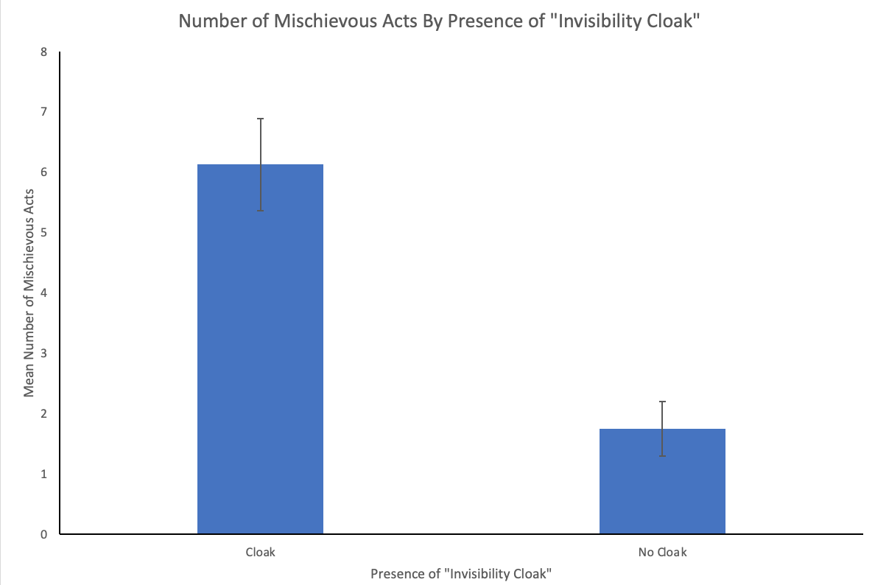

4. The same babysitter wants to test her hypothesis at a daycare. She is only working there for one day, so this time she gives half of the children an “invisibility cloak” and the other half don’t receive one. She counts up the number of mischievous acts each child engages in throughout the day. Is there a difference in the number of mischievous acts completed by children who were wearing a cloak compared to those who were not?

Mischievous Acts for Invisibility Cloak Group | Mischievous Acts without an invisibility Cloak.
4  3  6  6  8  5  5  4  2  5  7  5 | 3  1  5  4  6  4  6  2  0  5  4  5

A. What statistical test should you use to answer this question? Be as specific as possible.

Independent samples t-test

B. Write a sentence describing the overall result of the analysis, include statistical notation.

The analysis did not show a significant effect of presence of invisibility coat on mischievous acts, t(22) = 1.71, p = .101.

C. Write a sentence describing the specific difference between the groups, include group means.

Although mean number of mischievous acts was higher for the children who thought they were wearing an invisibility cloak (M = 5.00) than for the children who did not think they were wearing an invisibility cloak (M = 3.75), this difference was not significant.

D. Graph the means and SEM error bars for this data using Excel. Include chart title and both axis titles.

